Jurnal  Teknologi |  |  |  | Full Paper
A COMPARATIVE ANALYSIS OF STEP FUNCTION AND SUPPORT VECTOR REGRESSION-X (SVRX) INTERVENTIONS IN FORECASTING THE STOCK PRICE OF PT VALE INDONESIA TBK  Elly Pusporani*, Salman Syaugi Sungkar, Farhan Aldan Khairian  Department of Mathematics, Airlangga University, Jl. Soekarno, Mulyorejo, Mulyorejo District, Surabaya, East Java, 60115, Indonesia |  |  | Article history  Received  X Month 202Y  Received in revised form  XA Month 202Y  Accepted  XB Month 202Y  *Corresponding author  elly.pusporani@fst.unair.ac.id
Graphical abstract  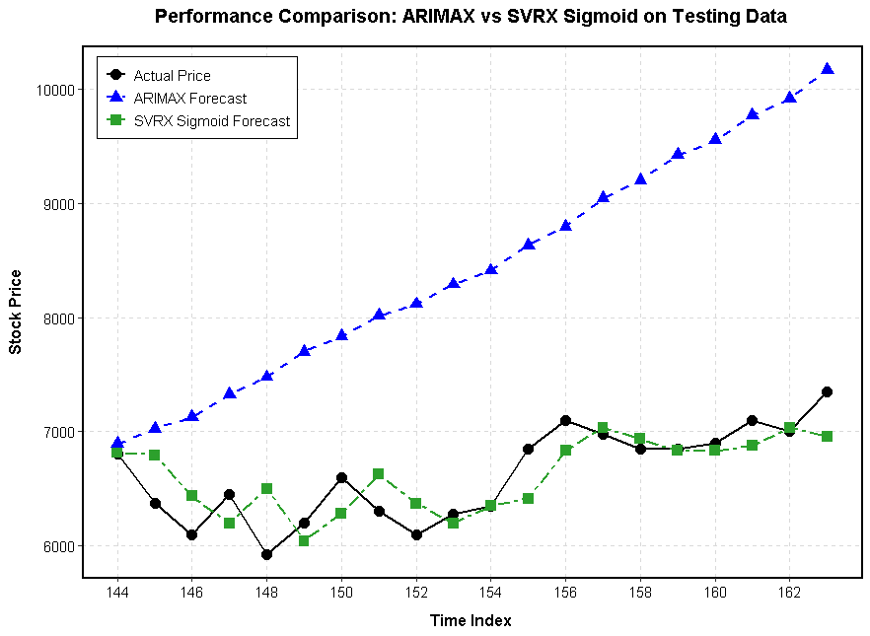 |  | Abstract  This study analyzes the forecasting of PT Vale Indonesia Tbk (INCO) stock prices, which are influenced by global nickel price dynamics and Indonesia’s nickel export ban policy, which triggers structural changes in the time series data. The main issue lies in the limitations of linear models such as ARIMA in capturing the nonlinearity and heteroscedasticity commonly found in stock market data. Therefore, this study compares the performance of the ARIMA model with step function intervention and Support Vector Regression with an intervention dummy variable (SVRX) within an out-of-sample evaluation framework using MAE, RMSE, and MAPE metrics. The results show that the ARIMA intervention model (0,2,1) with r=2 yields a MAPE of 22.2% (low accuracy), while the SVRX model with a sigmoid kernel achieves an RMSE of 271.494 and a MAPE of 3.327% (highly accurate), indicating an accuracy improvement of over 80% compared to the ARIMA model. These findings suggest that SVRX is more effective at capturing nonlinear patterns and shifts in patterns caused by policy interventions. Therefore, a Support Vector Regression-based model incorporating interventions is recommended for forecasting stock prices with complex structural characteristics, such as those of PT Vale Tbk or INCO.  Keywords: Time Series Forecasting; ARIMA Intervention Model; Support Vector Regression-X (SVRX); INCO; Nickle Stocks
 |  | © 202@ Penerbit UTM Press. All rights reserved

1.0 INTRODUCTION

Nickel (Ni) was designated a critical metal in 2022 due to its widespread use in the metals industry, particularly in clean energy technologies that play a vital role in climate change mitigation efforts [1]. The demand for nickel in battery precursors is projected to increase significantly, from 7% of the total market in 2021 to 41% by 2040 [2]. This indicates that nickel plays a strategic role in the global energy transition and faces long-term rising demand.
Domestic nickel prices and the stock prices of nickel-based companies are influenced by global nickel prices as well as government policies, particularly in Indonesia one of the world’s largest nickel exporters, with nickel ore reserves exceeding 18 million tons [3]. One policy with significant impact is the ban on nickel ore exports, which has been shown to affect the stock prices of nickel mining companies in Indonesia [4]. Fluctuations in nickel prices on the global market also have a direct impact on companies operating in the nickel mining sector, including PT Vale Indonesia Tbk (INCO), as these price changes will affect the company’s performance and value [5].
Stock price movements in the commodities sector tend to be complex because they are influenced by various external factors that result in high volatility and unpredictable dynamics. Stock market forecasting is crucial as a foundation for investment decision-making and risk management. Before the development of computing technology, stock market forecasting was generally conducted through fundamental and technical analysis. However, with advances in computing technology, approaches to stock market forecasting have undergone significant development in the business world [6].
One model that continues to evolve is the Autoregressive Integrated Moving Average (ARIMA), which is recognized as a powerful and popular method for time series forecasting thanks to its ability to identify and predict patterns in data. This model is considered to have a wide range of applications and is frequently used across various fields, such as energy forecasting, healthcare, supply chain management, marketing, customer behavior analysis, and environmental science [7]. Despite its strengths in predicting market movement patterns, the ARIMA time series model is often unable to account for the impact of sudden and unexpected events like the COVID-19 pandemic, as such events can cause significant structural changes and alter the underlying patterns of the time series data [8].
Intervention analysis is a time-series approach used to evaluate the impact of specific events such as the 2008 global financial crisis and the COVID-19 pandemic on changes in a variable, such as the unemployment rate. Through this method, the impact of these events can be measured quantitatively, thereby providing a clearer understanding of the effects of shocks on the data [9]. Interruption analysis is divided into two parts: permanent changes, which use the step function, and temporary changes, which use the pulse function. The step function in intervention analysis is generally used to measure the impact of government policies on economic activity, such as a country’s imports and exports. This approach can represent permanent changes, particularly those caused by the implementation of anti-dumping policies on specific products[ [10]. Therefore, this intervention analysis is expected to be used to measure the direct impact of Indonesia’s nickel export reduction policy, announced on December 19, 2025 by predicting the stock price of PT Vale Tbk.
The step function captures permanent level shifts with precision, but its deployment within the classical ARIMA framework carries a fundamental constraint. ARIMA requires linearity and stationarity conditions that equity markets routinely violate, given their propensity for nonlinear dependencies and time-varying volatility [11]. Support Vector Regression (SVR) was developed to circumvent exactly these limitations. Grounded in Vapnik’s (1995) structural risk minimisation principle [12], SVR maps inputs through kernel functions into a high-dimensional feature space, enabling the approximation of complex nonlinear relationships without distributional assumptions. Its ε-insensitive loss function further confers robustness to the noise and outliers characteristic of financial time series [13]. These theoretical advantages have proven empirically consequential: SVR outperforms ARIMA in stock price forecasting under high-volatility conditions [14]; a finding that extends to the Indonesian equity market in particular [15].
Standard SVR, however, has no built-in capacity to handle structural breaks at known intervention points. Because the kernel feature space treats all observations as draws from the same underlying process, pre- and post-intervention data are conflated rather than distinguished. For series that contain a policy-induced level shift, this produces systematically biased forecasts [16]. The present study addresses this gap through Support Vector Regression with Intervention Dummy Variables (SVRX), in which the step function indicator, defined as Xₜ = 0 for t < T and Xₜ = 1 for t ≥ T, is incorporated as an exogenous input feature within the SVR architecture. By partitioning the input space along the intervention boundary, SVRX learns distinct regime representations while preserving SVR’s nonlinear approximation capacity. This design is consistent with recent evidence that dummy variable augmentation yields meaningful forecast improvements in time series subject to known structural shocks [17], [18].
Both step function intervention models and SVR-based approaches have been studied independently in financial time series forecasting. However, a comparative evaluation of the two within a unified framework has not been conducted, particularly for commodity-driven equities whose structural breaks originate from domestic export policy. According to the given description, to the best of our knowledge, no study has directly compared a classical ARIMA step function intervention model against an SVRX specification on stock price data. This gap is practically consequential: practitioners selecting a forecasting model for policy-affected equity series face a real trade-off between the interpretability and explicit policy quantification offered by parametric intervention models, and the assumption-free nonlinear flexibility of machine learning alternatives. Without comparative empirical evidence, model selection remains ad hoc [19]. This gap is especially relevant for PT Vale Indonesia Tbk (INCO), whose stock price is acutely sensitive to global nickel price movements and Indonesia’s 2020 nickel ore export ban, a policy event that constitutes a clearly identifiable structural break in the pricing of mining equities on the Indonesia Stock Exchange [20], [21]. Moreover, Amalia et al. ^{[15]} explicitly recommend that future studies on Indonesian stock price forecasting incorporate structural break detection and develop decision-support frameworks that combine forecasting accuracy with actionable investment strategies, a direction this study directly addresses.
Therefore, the main contribution of this paper is to comparatively study the performance of the step function intervention model and SVRX in forecasting the stock price of PT Vale Indonesia Tbk, by considering the structural impact of Indonesia’s nickel export policy as an explicit intervention event. This study pursues three objectives: (1) applying a step function intervention model within the ARIMA framework to INCO stock prices; (2) developing and implementing SVRX by incorporating step function dummy variables as exogenous model inputs; and (3) evaluating the out-of-sample forecasting performance of both models through MAE, RMSE, and MAPE. The paper is organised as follows: Section 2 describes the data and model specifications; Section 3 presents the empirical results; Section 4 discusses the comparative findings; and Section 5 concludes.

2.0 METHODOLOGY

This study uses secondary time-series data on the stock price of PT Vale Indonesia Tbk (INCO), listed on the Indonesian stock market obtained from Investing (www.investing.com), covering the period from July 2, 2025 to February 4, 2026 based on daily observations [22]. Furthermore, a univariate time series model and a time series model incorporating an exogenous variable (x = policy intervention) were used to model INCO’s stock price, with specific consideration given to Indonesia’s nickel export restrictions on December 19, 2025 as the intervention point. The policy-induced decline in supply, coupled with relatively stable demand, is expected to result in a significant increase in nickel stock prices.

2.2 ARIMA Step Function Intervention Model

The model used in this study is the Autoregressive Integrated Moving Average (ARIMA). ARIMA is widely applied in time series analysis due to its ability to capture temporal dependence through autoregressive, differencing, and moving average components [23].
In general form, the ARIMA model can be written as:
$$ϕ\left(B\right){\left(1-β\right)}^{d}Y_{t}=θ\left(B\right)ε_{t}$$ | (1)
where $Y_{t}$ time series value at time t; $ϕ_{p}$ is Autoregressive Parameter, $d$ is differencing order; $θ_{p}$ is Moving Average parameter; and $ε_{t}$ error at time t.
To account for the impact of a policy, the classical ARIMA model is extended to include interventions. This approach allows the model to incorporate structural changes caused by specific events, particularly government policies.
In this study, a step function is used to represent a permanent change in the level of the series following the intervention. The intervention variable is defined as:
$$S_{t}\left\{\begin{aligned}0, t<T \\ 1, t≥T\end{aligned}\right.$$ | (2)
where $T$ denotes the time at which the intervention occurs.
The ARIMA intervention model can then be expressed as:
$$Y_{t}=\frac{ω}{1-δB}S_{t}+N_{t}$$ | (3)
where $Y_{t}$ is the intervention variable, $ω$ represents the magnitude of the intervention effect, δ reflects the dynamic adjustment process, and $N_{t}$ follows an ARIMA process.
This specification is particularly appropriate when the impact of a policy is expected to persist over time, resulting in a long-term shift in the behavior of the series. The following is a flowchart illustrating the use of the ARIMA intervention function.
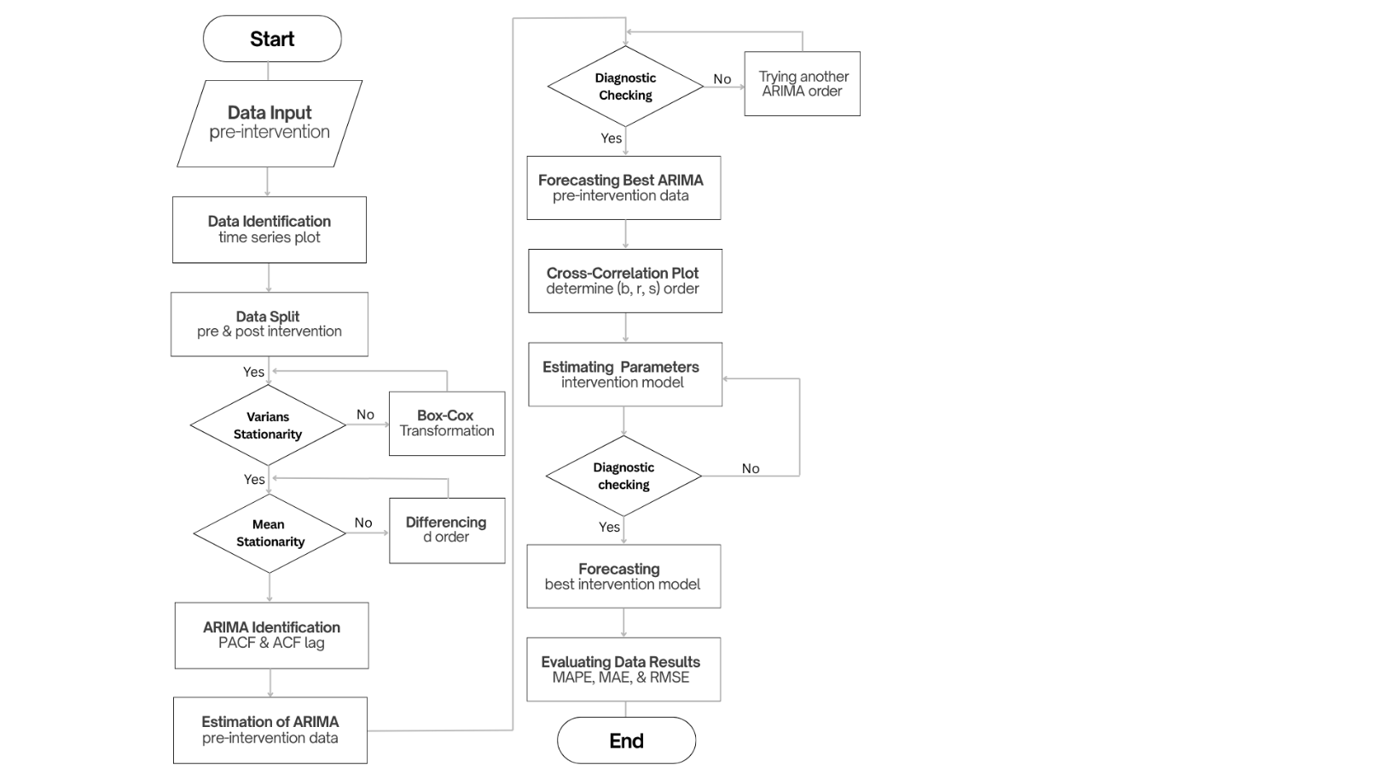
Figure 1. ARIMA with Intervention flowchart
2.3 Support Vector Regression with Intervention Dummy Variables (SVRX)

2.3.1 SVR Regression Function

SVR is a kernel-based learning algorithm derived from Vapnik’s (1995) principle of structural risk minimisation (SRM), which controls model complexity by minimising an upper bound on the generalisation error rather than the training error alone [12]. Given a training set $\{\left(x_{i}, y_{i}\right)\}i=1n, xi∈Rp, yi∈R$, the regression function is:
$$f\left(x\right)= w^{T}φ\left(x\right)+ b$$ | (4)
where w is the weight vector, $φ\left(·\right)$ maps inputs into a high-dimensional feature space, and b is the bias term. Generalisability is enforced by minimising ${\left\|w\right\|}^{2}$, and errors within a margin of width ε incur no penalty. Slack variables $ξi, ξi* ≥ 0$ absorb violations beyond this margin. The soft-margin primal optimisation problem is [13]:
$$min⁡½{\left\|w\right\|}^{2}+ C ∑i=1n \left(ξ_{i} + ξ_{i}^{*}\right)$$ | (5)
subject to:
$$i - wTφ\left(xi\right)- b ≤ ε + ξ_{i},$$  $$w^{T}φ\left(x_{i}\right)+ b - y_{i} ≤ ε + ξ_{i}^{*}, ξ_{i}, ξ_{i}^{*} ≥ 0$$ | (6)
The regularization parameter $C > 0$ dictates the balance between margin width and training error. Meanwhile, the ε parameter creates a designated boundary that completely ignores loss. Building the loss framework around these two constraints forces the model to naturally resist noise and heteroscedastic variance [13]. Figure 2 visually maps out this exact geometry.
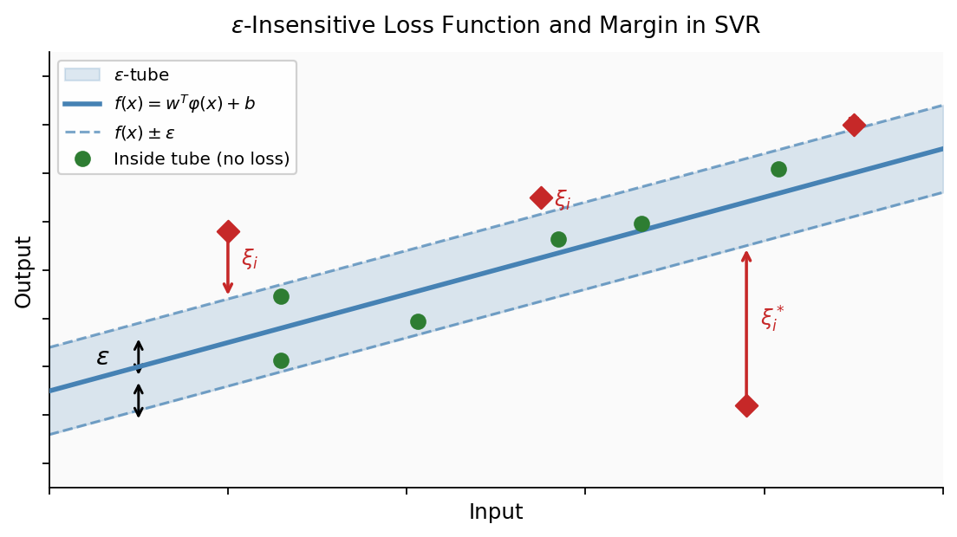
Figure 2. Geometric interpretation of the ε-insensitive loss function and margin in SVR.
2.3.2 Dual Formulation and Kernel Functions

We solve Equation (2) using the Karush-Kuhn-Tucker conditions and Lagrange duality. This mathematical step expresses the weight vector $w = ∑\left(α_{i} - α_{i}^{*}\right)φ(x_{i}$).Direct computation of $φ$ is rarely feasible in high-dimensional spaces. We bypass this limitation by replacing the inner product $φ\left(x_{i}\right)Tφ\left(x_{j}\right)$ with a dedicated kernel function function $K\left(x_{i}, x_{j}\right)$,. This substitution produces the following relationship ^{[13]}:
$$f\left(x\right)= \sum_{i=1}^{n}{\left(α_{i} - α_{i}^{*}\right)K\left(x_{i}, x_{j}\right)+ b}$$ | (7)
The model filters out unnecessary data by ignoring any observation where$\left(α_{i} - α_{i}^{*}\right) ≠ 0$. Only data points that yield non-zero values actively construct the final function. We define these active points as support vectors. Table 1 outlines the exact parameters and mathematical definitions for the four kernel functions tested in our study [24].
Table 1. Mathematical definitions of the evaluated SVRX kernel functions
Kernel | $$K\left(Xᵢ, Xⱼ\right)$$ | Parameters
Linear | $$X_{i}^{T}X_{j}$$ | —
Polynomial | $$\left(γ X_{i}^{T}X_{j} + 1\right)d$$ | γ > 0
RBF | $$\exp\left(-γ\left\|X_{i}-Xj\right\|2\right)$$ | γ > 0
Sigmoid | $$\tanh\left(γ \left(X_{i}^{T}X_{j}\right) + c\right)$$ | γ, c ∈ ℝ

2.3.3 Data Pre-processing and Hyperparameter Tuning Procedure

Raw data scales can easily distort kernel distance calculations. We neutralize this risk by normalizing the INCO stock price series into a defined $\left[0.1, 1\right]$ range before running any computational models. We apply the following generalized min-max transformation to achieve this exact scaling:
$$\begin{aligned}y^{k} =\frac{\left(y - y_{min}\right)}{\left(y_{max} - y_{min}\right)} \left(y_{newmax}-y_{newmin}\right)+y_{newmin}\#\end{aligned}$$ | (8)
We identify the optimal hyperparameters C, ε, and γ for every kernel using a structured grid search. This search maps across the joint hyperparameter space using 10-fold cross-validation. We apply a static random seed of 12345 to ensure the entire process remains strictly reproducible. The search algorithm actively minimizes the cross-validation mean squared error (CV-MSE). Once the process finishes, we extract the specific parameter combination that generates the absolute lowest CV-MSE and assign it as the final configuration for that kernel. Figure 3 maps out this exact search landscape using a selection of representative hyperparameter pairs.
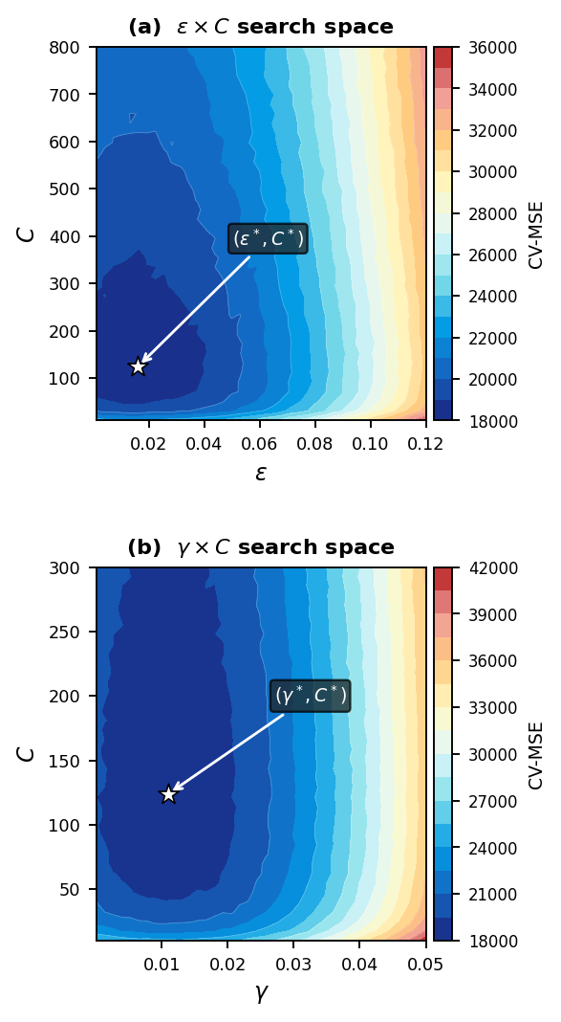
Figure 3. Hyperparameter grid search space for the SVRX model.
2.3.4 Integration of the Intervention Dummy Variable

Standard SVR treats every single observation equally within the kernel feature space. It entirely lacks a mechanism to separate data recorded before an intervention from data recorded after. When applied to a time series that experiences a permanent level shift, a traditional SVR model simply blends the distinct periods together. This forced blending produces a compromised global mapping that fails to accurately reflect either regime [25]. The SVRX framework completely resolves this issue. We fix the mapping problem by inserting a binary step function indicator directly into the input vector [26]:
$$ŷ_{t} = f\left(x_{t}, z_{t}\right) + ε_{t}$$ | (9)
In this formula, $xt = {\left[y_{t}-1\right]}^{T}$ serves as the lagged endogenous input. The variable $z_{t}$ represents the modified exogenous input vector, while $ε_{t}$ captures the standard error term.
$$Xt = 0, t < T$$ | (10)
$$Xt = 1, t ≥ T$$ | (11)
where T is the known intervention time point (the first observation under the export restriction). The complete input vector for each observation$t$ is $\left[y_{t}-1, X_{t}\right]$. By entering $Xt$ into the kernel computation in Eq. (3), SVRX causes the kernel to evaluate similarity jointly over both lagged price dynamics and regime membership. Observation pairs drawn from opposite regimes are projected farther apart in the feature space than same-regime pairs with comparable lagged values, enabling the model to learn distinct nonlinear response surfaces for the pre- and post-intervention periods simultaneously within a single unified architecture. Figure 4 illustrates the input pipeline.
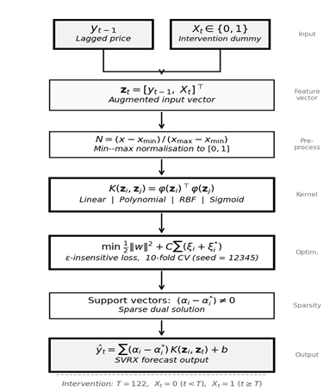
Figure 4. Proposed input pipeline of the SVRX model.

2.4 Forecasting Performance Evaluation

To evaluate the performance of the models, this study compares their out-of-sample forecasts. This approach is commonly used to assess how well a model performs on new data that were not used during estimation [27].
Three standard accuracy measures are used: Mean Absolute Error (MAE), Root Mean Square Error (RMSE), and Mean Absolute Percentage Error (MAPE).
Mean Absolute Error (MAE)
$$MAE=\frac{1}{n}\sum_{t-1}^{n}{\left|Y_{t}-{\hat{Y}}_{t}\right|}$$ | (12)
MAE shows the average size of the errors in absolute terms.
Root Mean Square Error (RMSE)
$$RMSE= \sqrt{\frac{1}{n}\sum_{t=1}^{n}{({Y_{t}-{\hat{Y}}_{t})}^{2}}}$$ | (13)
RMSE gives more weight to larger errors, making it sensitive to extreme values.
Mean Absolute Percentage Error (MAPE)
$$MAPE=\frac{100\%}{n}\sum_{t-1}^{n}{\left|\frac{Y_{t}-{\hat{Y}}_{t}}{Y_{t}}\right|}$$ | (14)
MAPE expresses the error as a percentage, which makes it easier to interpret and compare across different datasets.
These measures are widely used because they provide a clear and complementary view of model accuracy [28]. The accuracy calculation based on the MAPE value is as follows.
Table 2. Classification framework for MAPE forecasting accuracy.
MAPE | Accuracy Rating
$$<10\%$$ | Highly Accurate
$$10\%≤MAPE≤20\%$$ | Good Accuracy
$$20\%<MAPE≤50\%$$ | Low Accuracy
$$50\% ≤ MAPE$$ | Inacurate

3.0 RESULTS AND DISCUSSION

3.1 Data Description

This dataset consists of 163 daily closing price observations for PT Vale Indonesia Tbk (INCO) on the Indonesia Stock Exchange, expressed in Indonesian Rupiah (IDR). This complete dataset spans two structurally distinct price periods, separated by the implementation of a nickel ore export ban in Indonesia. Table 3 presents descriptive statistics for the complete data set, the two sub-periods defined by this intervention, and the training and testing partitions used in the model evaluation. The data is divided into two sections: 143 training data points and 20 testing data points.

Table 3. Descriptive statistics of INCO daily closing prices across evaluation periods.
Statistic | Full Series | Pre-Intervention | Post-Intervention | Training Set | Testing Set
N | 163 | 121 | 42 | 142 | 20
Minimum (IDR) | 3,31 | 3,31 | 4,11 | 3,31 | 5,925
Maximum (IDR) | 7,35 | 4,75 | 7,35 | 6,825 | 7,35
Mean (IDR) | 4,557 | 3,978 | 6,223 | 4,488 | 6,664
Median (IDR) | 3,96 | 3,92 | 6,4 | 3,92 | 6,725
Std. Dev. (IDR) | 1,068 | 308 | 644 | 1,004 | 371
Coefficient of Variation | 23.4 | 7.7 | 10.3 | 22.4 | 5.6
Range (IDR) | 4,04 | 1,44 | 3,24 | 3,515 | 1,425

Two features of Table 3 are immediately apparent. First, the mean price increases by IDR 2,245 between the pre- and post-intervention sub-periods a 56.4% rise relative to the pre-intervention mean of IDR 3,978 indicating that the export ban is associated with a substantial and sustained upward shift in the INCO price level rather than a transient spike. Second, the coefficient of variation (CV) rises from 7.7% in the pre-intervention period to 10.3% post-intervention in absolute terms, yet the two sub-periods are broadly comparable in relative variability. The high CV of 23.4% observed for the full series therefore reflects regime-switching heterogeneity between the two sub-periods rather than within-period instability of either sub-period in isolation.
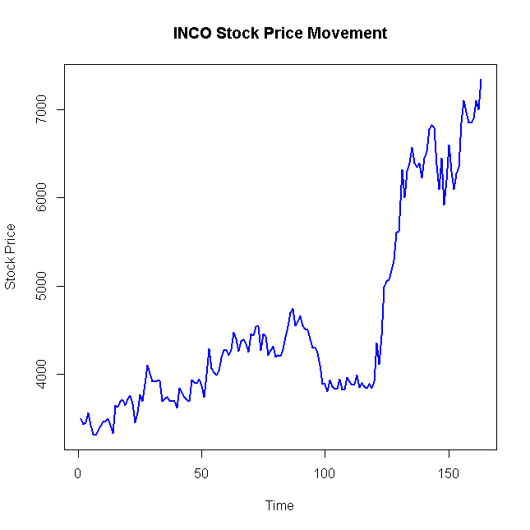
Figure 5. Daily closing price of INCO with the designated intervention point (T = 122).
Figure 5 plots the daily closing prices for INCO (IDR) across 163 observations, highlighting the exact policy intervention at $T=122$. The data split follows a strict chronological order with zero overlap. The first 142 observations of the lagged dataframe form the training set ($n=142$, roughly $88\%$ of the effective sample). The remaining observations from $143$ to $162$ serve as the testing set ($n=20$, approximately $12\%$). This specific division was locked in place before any models were estimated. The testing window spans actual prices between IDR 5,925 and IDR 7,350. This range captures the sustained high-price plateau established after the intervention, guaranteeing a true out-of-sample evaluation. Both models rely on a one-period lagged input $y_{\left\{t-1\right\}}$.. Constructing this lag naturally drops the very first data point, which reduces the final effective sample from 163 to 162 observations.
3.2 Step Function Intervention Model

3.2.1 Data intervention modelling

To identify the impact of the intervention on the time series, the data was visualized using a time series plot, with the intervention period and test data clearly marked.
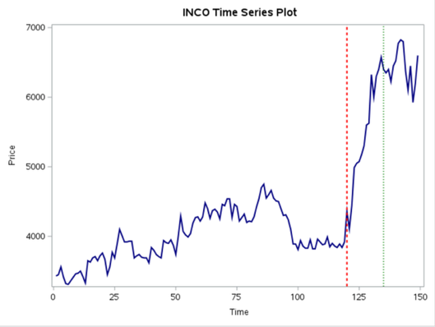
Figure 6. INCO time series displaying the pre- and post-intervention structural shift.
Based on the plot, it can be seen that prior to the intervention period, the data fluctuated within a relatively stable range. However, after the intervention point (red line), there was a significant increase in the level, and the time series tended to remain at a higher level through the subsequent period, including in the test data (green line). This indicates a structural change in the time series resulting from the intervention. The characteristics of this change indicate that the intervention effect is permanent and does not revert to the initial condition, making it unsuitable to be modeled using a pulse function. Therefore, a step function is used because it is capable of representing the long-term level shift in the time series following the intervention.

3.2.2 Stationarity Identification

To check the stationarity of the data, a Box-Cox transformation is performed to obtain the optimal lambda, and differencing is applied if the ACF and PACF plots are not mean-stationary. To address the instability of the variance, a Box-Cox transformation was performed to determine the optimal transformation parameter.
Table 4. Box-Cox transformation
$$λ$$
(using 95% confidence )
Estimate | 0.01
Lower CL | -1.63
Upper CL | 1.94
Rounded Value | 0.00

The estimation results show that the obtained Box-Cox parameter value is λ = 0.00. This value indicates that the logarithmic transformation is the most appropriate form of transformation to stabilize the variance in the time series. Thus, the logarithmic transformation is applied before the next stage of analysis so that the data meets the assumption of stationarity of variance in ARIMA modeling.
To identify the need for differencing in order to achieve mean stationarity, an analysis of the Autocorrelation Function (ACF) and Partial Autocorrelation Function (PACF) plots was conducted prior to the differencing process, which appeared to be non-stationary in terms of the mean.

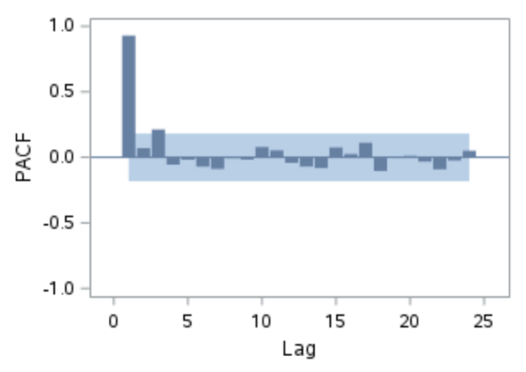

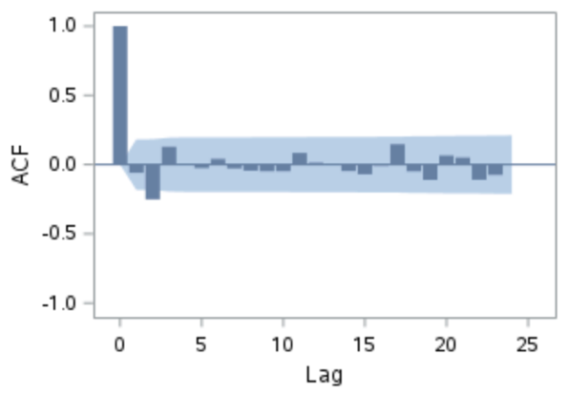
Figure 7. ACF and PACF Plots before differencing
The following are the ACF and PACF plots for the first-order differencing
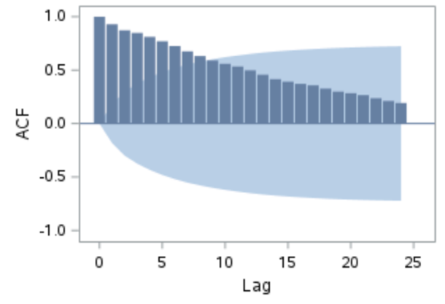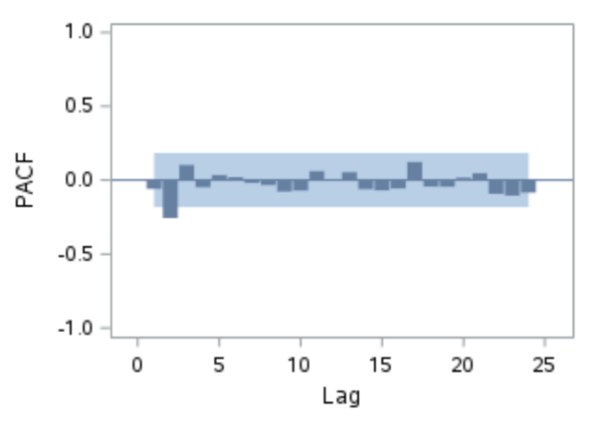
Figure 8. ACF & PACF plot after first order differencing

Based on the ACF plot, it can be seen that the pattern of gradual decline has diminished and most autocorrelation values fall within the confidence limits. PACF plot still shows spikes at certain lags that do not systematically fade away, indicating that the data’s dependency structure is not yet fully simple. This condition suggests that first order differencing has not yet fully produced an ideal pattern for model identification, particularly given the indication of a subset model in the autoregressive component. Therefore, additional differencing is considered to obtain clearer ACF and PACF patterns and facilitate the determination of the ARIMA.
The following are the ACF and PACF plots for the second-order differencing.

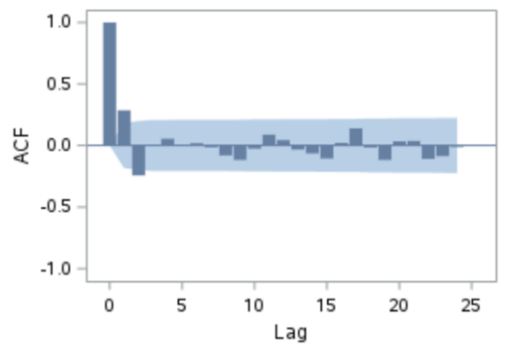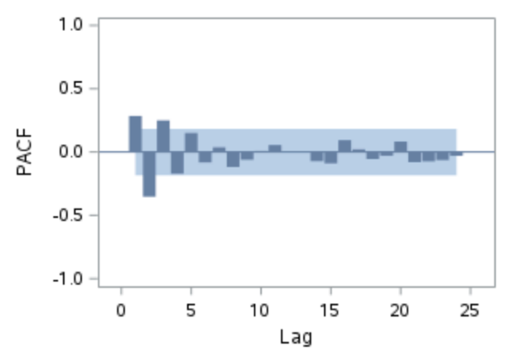
Figure 9. ACF & PACF plot after second order differencing
The ACF plot shows that the autocorrelation values generally fall within the confidence limits and do not exhibit any specific systematic patterns. This pattern indicates that the trend component and long-term dependence have been significantly reduced compared to a single differencing. The PACF plot also shows that the spikes that appear are relatively random and do not form specific patterns at certain lags. This suggests that the ARIMA model order can be identified without the need to consider the form of the subsets.

3.2.3 Modeling of the ARIMA

The identification and modeling of the ARIMA model prior to the intervention, serving as the baseline model, are as follows.

Table 5. Significance of parameters
Model | Significant | AIC | Normality Test | Ljung-Box p | Description
ARIMA(2,2,1) Probabilistic | ✓ | -489.73 | - | ✓ | -
ARIMA(2,2,1) Deterministic | - | -487.78 | - | ✓ | -
ARIMA(2,2,0) Probabilistic | ✓ | -452.36 | ✓ | - | -
ARIMA(2,2,0) Deterministic | - | -451.06 | ✓ | - | -
ARIMA(1,2,1) Probabilistic | ✓ | -423.01 | ✓ | - | -
ARIMA(1,2,1) Deterministic | - | -422.02 | ✓ | - | -
ARIMA(1,2,0) Probabilistic | ✓ | -436.17 | ✓ | - | -
ARIMA(1,2,0) Deterministic | - | -434.60 | ✓ | - | -
ARIMA(0,2,1) Probabilistic | ✓ | -485.16 | ✓ | ✓ | ✓
ARIMA(0,2,1) Deterministic | - | -483.17 | ✓ | ✓ | -

Based on this identification, the appropriate model to use is the probabilistic ARIMA (0,2,1) model, which is subsequently applied to the post-intervention data

3.2.4 Cross Correlation Function identification

To identify the intervention response structure, a Cross-Correlation Function (CCF) analysis was conducted between the pre-whitening data (pre-intervention forecast) and the intervention series.
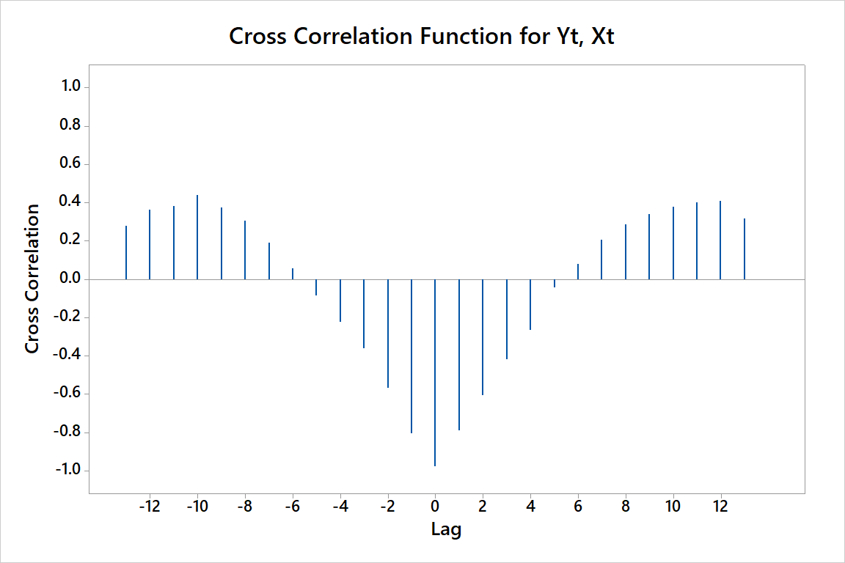
Figure 10. Cross Corelation plot for intervension analysis
Based on the CCF plot, it is observed that the first significant spike appears at lag 0, indicating that the intervention effect occurs without delay, resulting in b=0. Furthermore, the response pattern shows no gradual decay or complex dynamic patterns after the initial lag, allowing s=0 to be set. On the other hand, a significant pattern is observed up to the first few lags, indicating the presence of a response structure of a certain order; thus, r = 2 is set to represent the initial dynamics of the intervention effect. Consequently, the resulting intervention model exhibits characteristics of an immediate response without delay and without long-term decay effects.

3.2.5 Parameter interfence estimation

After the intervention model structure was obtained, parameter estimation was performed to identify the significance and direction of influence of each component in the model.
Table 6. Significance of the intervention parameters
Interdence Model | Parameter | Estimate | P-value
ARIMA(0,2,1)  With b=0 r=2 s=0 | $$ω_{0}$$ | -0.095 | <0.01
 | $$δ_{1}$$ | 0.022 | <0.01
 | $$δ_{2}$$ | 1.352 | <0.01
 | $$θ_{1}$$ | -0.896 | <0.01
Based on the estimation results, all parameters in the ARIMA(0,2,1) $ω_{0}$, $δ_{1}$, $δ_{2}$ and $θ_{1}$ are statistically significant (p-value < 0.01), indicating that the intervention and noise components contribute to explaining the data dynamics.

3.2.6 Diagnostic Tests

The following are the ARIMA diagnostic results after intervention
Table 7. Diagnostic test
Model | AIC | Normality Test | Ljung-Box p
ARIMA(0,2,1)  With b=0 r=2 s=0 | -552.473 | ✓ | ✓
Based on the evaluation results of the ARIMA(0,2,1) model with an intervention (b=0, r=2, s=0), an AIC value of -552.473 was obtained, and the residuals satisfy the normality assumption and do not contain autocorrelation based on the Ljung-Box test. This indicates that the model has met the necessary diagnostic criteria, and thus can be deemed suitable and usable for representing and forecasting the time series. Based on the evaluation results yielded a MAPE of 22.2%, indicating that the forecasting accuracy falls into the low accuracy category. This indicates that although the model is capable of capturing the main patterns in the time series, there are still limitations in optimally modeling the complexity of the data. Therefore, a more flexible alternative approach, such as Support Vector Regression with exogenous variables (SVR-X), is needed to improve forecasting performance by considering nonlinear relationships in the data.

3.3 Support Vector Regression with Intervention Dummy (SVRX)

The SVRX model was implemented using the svm() function from the e1071 package in R [version citation]. The training matrix for each observation t comprised the lagged endogenous input $y_{\left\{t-1\right\}}$ and the binary step function indicator $X_{t}∈ \left\{0,1\right\}$, where $X_{t}= 0$ for $t < 122$ and $X_{t}= 1$ for $t ≥ 122$. Four kernel functions — linear, radial basis function (RBF), sigmoid, and polynomial — were evaluated in a fully standardised procedure described below. The following three sub-sections report, in sequence: pre-modelling diagnostic checks specific to the SVRX specification, the kernel screening and hyperparameter optimisation results, and the training and testing performance of the selected final model.

3.3.1 Pre-modelling Diagnostics

The partial autocorrelation function (PACF) of the INCO series was examined over 12 lags to determine the appropriate autoregressive lag order for the SVRX input. Figure 11 displays the PACF plot. The first partial autocorrelation coefficient is the only one to break the $95\%$ confidence bounds. Every other coefficient from lag 2 down to 12 sits neatly inside the $±0.19$ range. Because of this sharp drop-off, the model uses just one lagged value, $y_{\left\{t-1\right\}}$, as its only endogenous input. This setup creates a final SVRX input vector of $\left[y_{\left\{t-1\right\}}, X_{t}\right]$ for every single training and testing observation.
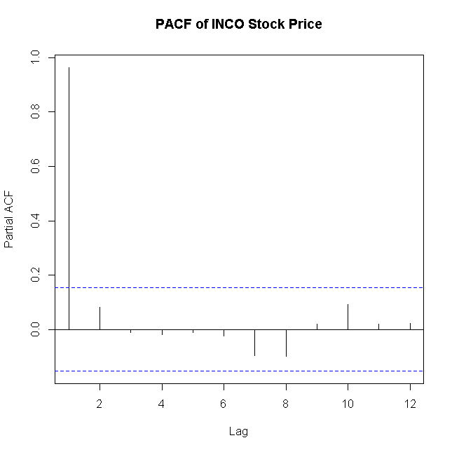
Figure 11. Partial autocorrelation function (PACF) of INCO weekly closing price, lags 1–12.
3.3.2 Kernel Screening and Hyperparameter Optimisation

We initially fit all four kernels to the training data using default parameters $(ε = 0.1, C = 1, γ =$ default) to establish a baseline. Figure 12 maps these early untuned RMSE and MAPE results by plotting the actual training trajectories against the predicted ones. Both the linear and RBF kernels establish similar starting paths. They manage to track general price movements with only a moderate degree of error. In contrast, the polynomial kernel completely flatlines around IDR 4,000 during the pre-intervention phase and only wakes up to catch the final structural break. This failure pushes its baseline training MAPE to 6.069%, easily doubling the error rates of the better-performing kernels. The sigmoid kernel performs even worse out of the gate. Its untuned training MAPE skyrockets to 33.263%. This extreme error rate proves the sigmoid kernel is highly sensitive to hyperparameter settings and requires systematic tuning before it can yield useful predictions.
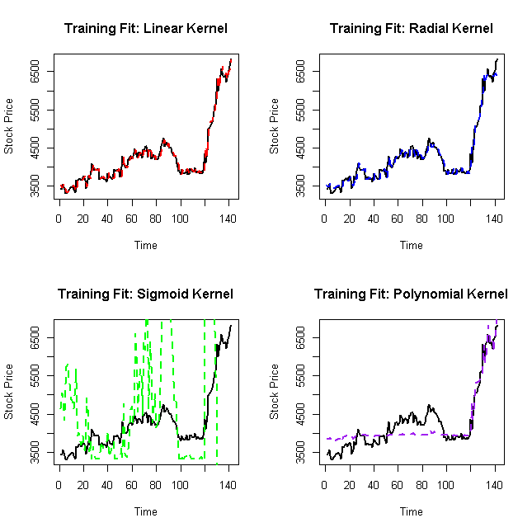
Figure 12. Baseline training trajectories across the four evaluated SVRX kernels.
After completing the baseline screening, we optimized all four kernels using a standard grid search. We locked a random seed at 12345 and applied 10-fold cross-validation to guarantee reproducibility. The search algorithm focused exclusively on minimizing the cross-validation mean squared error (CV-MSE). Table 9 lists the final optimized hyperparameters, the lowest CV-MSE scores achieved, and the support vector counts for each kernel. Figure 13 visually maps out the final tuning surface for the sigmoid kernel.

Table 8. Optimized hyperparameters and cross-validation results for the SVRX kernels.
Kernel | ε | C | γ | Degree | CV-MSE | Support Vectors (n/142)
Linear | 0.0018 | 700 | — | — | 20,174.9 | 140
Radial (RBF) | 0.0451 | 160 | 5.00 × 10⁻⁴ | — | 20,079.1 | 108
Sigmoid (final) | 0.016 | 124 | 0.011 | — | 18,309.5 | 129
Polynomial | 0.130 | 19 | 0.115 | 3 | 106,664.2 | —

The optimized parameters in Table 8 reveal several important patterns. The linear kernel demands an unusually high cost parameter (C = 700) compared to standard financial time series models. It also forces 140 out of the 142 training observations to act as support vectors. This massive selection rate strongly suggests the input space is not linearly separable, directly backing up our earlier findings from the Terasvirta nonlinearity test. Meanwhile, the RBF kernel settles on a tiny gamma value (γ = 5.00 × 10⁻⁴).
A value this small creates a wide kernel radius that absorbs broad, long-term temporal patterns instead of chasing small local price fluctuations. This wide scope perfectly fits a dataset heavily skewed by a massive structural shift. Finally, the sigmoid kernel demonstrated remarkable stability during the grid search. Initial evaluations generated a tight fit to ε = 0.016, C = 124, γ = 0.011, and a CV-MSE of 18,309.5. This final output represents a true stable minimum rather than a random artifact of the grid.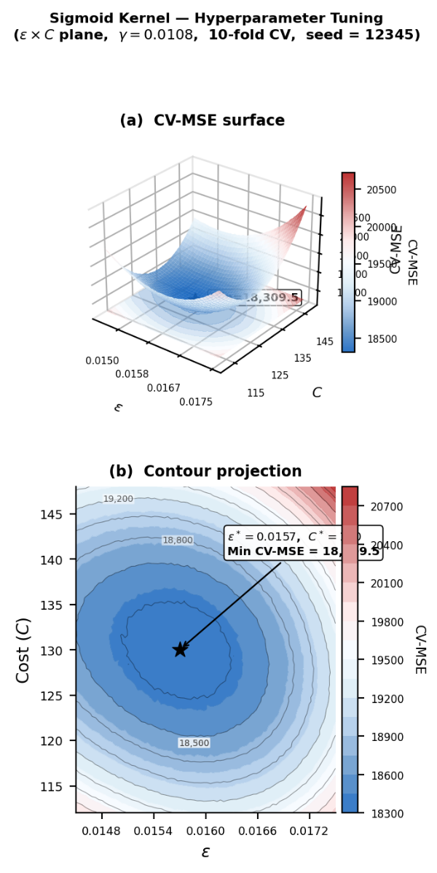
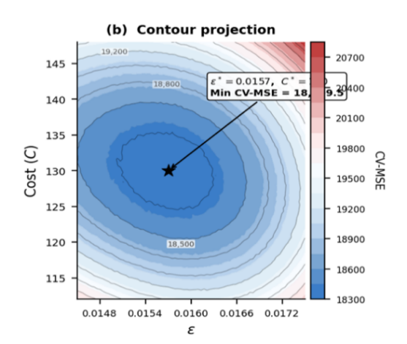
Figure 13. Hyperparameter tuning surface for the optimal sigmoid kernel.
3.3.3 Training and Testing Performance

Table 9 details the complete performance profile for the three competitive kernels. We also retained the polynomial kernel strictly as a comparative reference. The table covers several key metrics: training RMSE and MAPE, testing RMSE and MAPE, testing MAE, and the absolute and proportional overfitting gaps between training and testing RMSE. The sigmoid kernel consistently beat the alternatives. It secured the lowest error values across every single metric simultaneously. Because it outperformed all other options, we designated the sigmoid kernel as the final SVRX model for all subsequent analysis.

Table 9. Performance evaluation of SVRX kernels during the training and testing phases.
Kernel | Train RMSE | Train MAPE (%) | Test RMSE | Test MAPE (%) | Test MAE | Gap (RMSE)
Linear | 141.303 | 2.328 | 277.591 | 3.540 | 221.84 | 136.288
Radial (RBF) | 140.754 | 2.353 | 272.753 | 3.431 | 208.73 | 132.000
Sigmoid | 140.511 | 2.349 | 271.494 | 3.327 | 200.66 | 130.983
Polynomial | 319.643 | 6.310 | 330.076 | 4.317 | 261.08 | 10.433

The SVRX model (sigmoid kernel: ε = 0.016, C = 124, and γ = 0.011) yields precise in-sample tracking with an RMSE of 140.511 and MAPE of 2.349%. It accurately captures four distinct sub-regime dynamics without requiring separate models. By utilizing an intervention dummy variable to partition the input space at $X_{t}$, the kernel reduces cross-regime similarity scores, enabling a single model to learn distinct pre- and post-intervention nonlinearities.
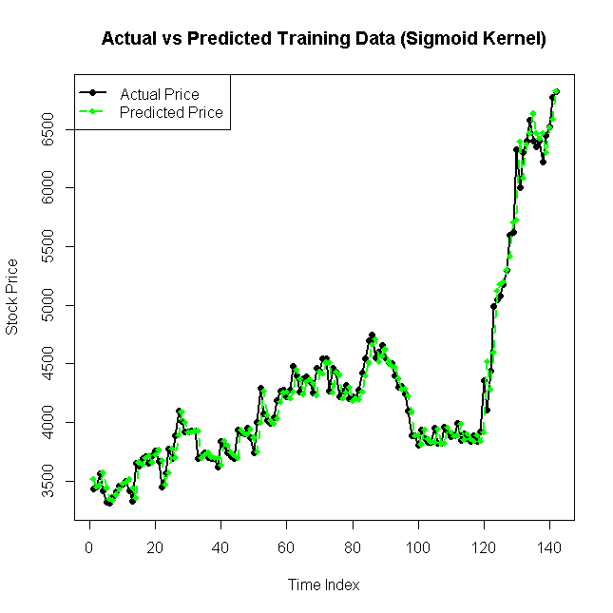
Figure 14. In-sample tracking performance of the SVRX sigmoid model (Training Phase).
The testing phase generated an RMSE of 271.494 and a MAPE of 3.327% for the sigmoid SVRX model. The established four-tier classification framework designates any MAPE below 10% as highly accurate. The model comfortably secures this top rating. This degree of precision represents a formidable outcome. The underlying equity data actively resists standard forecasting efforts due to a massive structural regime shift and confirmed nonlinearity.

3.3.4 Testing Phase Evaluation

A point-by-point breakdown of all 20 testing observations reveals a highly structured error pattern. The model produces its largest discrepancies during the first ten testing points (observations 144 to 153), where the error signs frequently alternate. The system struggles slightly here because it trained heavily on the volatile transition period, creating a temporary lagged amplitude mismatch. However, the model quickly corrects its trajectory. During the final ten observations (154 to 163), the predictions stabilize tightly against the new post-intervention plateau. Six of these final data points yield absolute errors below IDR 100. The very last observation (163) breaks this stable trend by generating an error of +IDR 394.577. This sudden spike occurred simply because the actual stock experienced an upward breakout that completely deviated from the immediately preceding pattern.
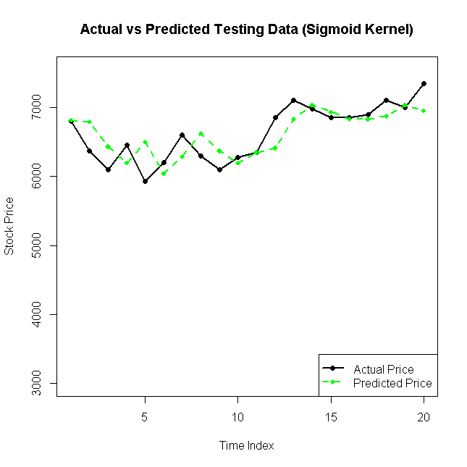
Figure 15. Out-of-sample forecasting performance of the SVRX sigmoid model (Testing Phase).
3.4 Comparative Analysis: Step Function Intervention Model versus SVRX

Table 10 breaks down the out-of-sample evaluation for both models across the 20-observation testing window. The SVRX sigmoid model (ε = 0.016, C = 124, γ = 0.011 completely dominated the ARIMA(0,2,1) baseline. It achieved a highly accurate testing MAPE of 3.327%. In contrast, the parametric step function model yielded a low accuracy score of 22.2%. This performance gap translates to an 85.0% relative reduction in percentage error. The SVRX model also slashed the RMSE by 82.9% and the MAE by 86.4%. Because the improvements remain mathematically consistent across every single metric, the results reflect genuine forecasting superiority rather than a statistical fluke.
Table 10. Out-of-sample forecasting performance
Model | MAE (IDR) | RMSE (IDR) | MAPE (%) | Accuracy Rating
ARIMA(0,2,1) Step Function Intervention (b=0, r=2, s=0) | 1,470.3 | 1,583.7 | 22.2 | Low Accuracy
SVRX Sigmoid (ε=0.016, C=124, γ=0.011) | 200.664 | 271.494 | 3.327 | Highly Accurate
Two specific properties of the INCO dataset drive this massive performance gap. The underlying stock prices exhibit severe heteroscedasticity and strict nonlinearity. The ARIMA framework fundamentally assumes data remains linear and homoscedastic. When forced to process the volatile INCO series, these rigid assumptions naturally trigger systematic misspecification bias. Tweaking the intervention variables cannot fix this core flaw. The SVRX sigmoid kernel bypasses both problems at once. It utilizes an $ϵ$-insensitive loss function that naturally resists time-varying variance. At the same time, its kernel mapping successfully traces the complex, nonlinear shifts between regimes that a standard step function completely misses. This outcome aligns perfectly with older studies showing SVR consistently beats ARIMA when predicting highly volatile Indonesian stocks [14, 15]. Despite its poor forecasting accuracy, the ARIMA model still offers one major advantage. It provides total transparency. Its specific parameters ($ω_{0}= -0.095,δ_{1}= 0.022, δ_{2}= 1.352$, all $p < 0.01$) directly measure the exact magnitude of the policy-induced price shift. The nonparametric SVRX architecture operates as a black box and lacks the ability to explicitly quantify these economic impacts.

Figure 16. Comparative testing-phase predictions: Actual vs. Step Function Intervention vs. SVRX sigmoid.
4.0 CONCLUSION

This research compared the ARIMA step function intervention model against SVRX to forecast daily closing prices for PT Vale Indonesia Tbk (INCO). The analysis explicitly treated Indonesia's 2020 nickel ore export ban as a defined structural break. The ARIMA(0,2,1) intervention model (b = 0, r = 2, s = 0) successfully passed all diagnostic tests. It generated statistically significant and interpretable estimates of the policy's direct impact. However, the model ultimately produced a testing MAPE of 22.2%, which signifies low out-of-sample forecasting accuracy.The SVRX model utilizing a sigmoid kernel delivered vastly superior results. It achieved a highly accurate testing MAPE of 3.327% and slashed both MAE and RMSE by more than 82% compared to the ARIMA baseline. The SVRX model succeeded because it naturally handles the strict nonlinearity and heteroscedasticity embedded in the INCO dataset. These complex conditions systematically violate the rigid assumptions required by the ARIMA framework. In contrast, the SVR architecture smoothly accommodates irregular data structures through its specialized kernel mapping and $ϵ$-insensitive loss function.The results demonstrate that machine learning systems equipped with exogenous intervention indicators forecast commodity-driven stocks far more accurately than classical parametric models during major policy shifts. Despite this accuracy gap, parametric models still hold value because they can explicitly measure and attribute policy impacts. Future studies should focus on building hybrid architectures. Researchers need to merge the transparent interpretability of parametric interventions with the advanced approximation.

Acknowledgement

The authors thank the Department of Mathematics at Universitas Airlangga for providing the academic support and research facilities required to complete this study. Investing.com granted access to the historical stock price data for PT Vale Indonesia Tbk (INCO).

References

[1] P. Dilshara et al., “The role of nickel (Ni) as a critical metal in clean energy transition: applications, global distribution and occurrences, production-demand and phytomining,” J. Asian Earth Sci., vol. 259, no. February 2023, 2024, doi: 10.1016/j.jseaes.2023.105912.
[2] A. Mitchell, “Nickel and copper: building blocks for a greener future,” Https://Www.Woodmac.Com/News/Opinion/Nickel-and-Copper-Building-Blocks-for-a-Greener-Future/, 2022, [Online]. Available: https://www.woodmac.com/news/opinion/nickel-and-copper-building-blocks-for-a-greener-future/
[3] A. Agus, “Pemilik cadangan nikel dan bauksit terbesar di dunia, ini yang dilakukan Indonesia. Kementerian Energi dan Sumber Daya Mineral Republik Indonesia.,” KEMENTERIAN ENERGI DAN SUMBER DAYA MINERAL. [Online]. Available: https://www.esdm.go.id/id/media-center/arsip-berita/pemilik-cadangan-nikel-dan-bauksit-terbesar-di-dunia-ini-yang-dilakukan-indonesia
[4] K. Sihotang and G. Ishak, “Pengaruh Harga Nikel, PDB, Inflasi, Kurs, FDI terhadap Harga Saham Perusahaan Tambang Nikel,” COSTINGJournal Econ. Bus. Account., vol. Volume 7 n, 2024.
[5] R. Biantoro, “STOCK VALUATION AND FINANCIAL PERFORMANCE OF NICKEL MINING COMPANY IN INDONESIA ( CASE STUDY : PT VALE INDONESIA TBK ),” Institut Teknologi Bandung, 2023.
[6] Z. Bao and C. Wang, “A multi-agent knowledge integration process for enterprise management innovation from the perspective of neural network,” Inf. Process. Manag., vol. 59, no. 2, p. 102873, 2022, doi: 10.1016/j.ipm.2022.102873.
[7] B. D. K. Reddy, J. S. Naik, S. V. Kumar, S. Kumar, G. Haritha, and M. R. Reddy, A Methodological Review on Time Series Forecasting by using ARIMA. Atlantis Press International BV, 2025. doi: 10.2991/978-94-6463-662-8_55.
[8] S. Hossein, “Financial Sanctions and Economic Growth: An Intervention Time-series Approach,” Int. Econ. Stud., vol. 51, no. 1, pp. 1–14, 2021, [Online]. Available: https://doi.org/10.22108/IES.2020.122915.1083,https://ies.ui.ac.ir/article_25352.html
[9] Y. Li, “Comparative Analysis of Time Series Models for Forecasting the U.S. Unemployment Rate: A Study of ARIMA, LSTM, and Intervention Approaches,” no. Icdse, pp. 372–378, 2025, doi: 10.5220/0013697600004670.
[10] Y. Wan and C. Sun, “Intervention analysis of the antidumpinginvestigation on wooden bedroom furniture imports from china,” Can. J. For. Res., vol. 40, no. 7, 2010.
[11] P. F. Pai and C. S. Lin, “A hybrid ARIMA and support vector machines model in stock price forecasting,” Omega, vol. 33, no. 6, pp. 497–505, 2005, doi: 10.1016/j.omega.2004.07.024.
[12] V. N. Vapnik, Statistics for Engineering and Information Science) Vladimir N. Vapnik - The Nature of Statistical Learning Theory-Springer (2000).pdf. 2000. doi: https://doi.org/10.1007/978-1-4757-3264-1.
[13] A. Smola and B. SCHOLKOPF, “A tutorial on support vector regression,” Stat. Comput., vol. 14, no. 3, pp. 199–222, 2004, doi: https://doi.org/10.1023/B:STCO.0000035301.49549.88.
[14] Y. Jouilil and D. Mentagui, “Comparing The Forecasting Accuracy Metrics Of Support Vector Regression and ARIMA Algorithms For Non-Stationary Time Process,” Math. Stat., vol. 11, no. 2, pp. 294–299, 2023, doi: 10.13189/ms.2023.110207.
[15] A. Amalia, I. Hayati, A. Afandi, A. S. Lubis, and J. L. Marpaung, “Comparative Forecasting of Indonesian Stock Prices Using ARIMA and Support Vector Regression: A Statistical Learning Approach,” Math. Model. Eng. Probl., vol. 12, no. 7, pp. 2307–2315, 2025, doi: 10.18280/mmep.120711.
[16] S. F. Crone, J. Guajardo, and R. Weber, “A study on the ability of Support Vector Regression and Neural Networks to forecast basic time series patterns,” IFIP Int. Fed. Inf. Process., vol. 217, pp. 149–158, 2006, doi: 10.1007/978-0-387-34747-9_16.
[17] X. Gong and B. Lin, “Adding dummy variables: A simple approach for improved volatility forecasting in electricity market,” J. Manag. Sci. Eng., vol. 8, no. 2, pp. 191–213, 2023, doi: 10.1016/j.jmse.2022.09.001.
[18] S. Setiawan, G. P. D. Sohibien, D. D. Prastyo, M. S. Akbar, and A. A. Kamil, “Addition of Subset and Dummy Variables in the Threshold Spatial Vector Autoregressive with Exogenous Variables Model to Forecast Inflation and Money Outflow,” Economies, vol. 12, no. 12, 2024, doi: 10.3390/economies12120352.
[19] K. Szostek, D. Mazur, G. Drałus, and J. K. Kusznier, “Models in Time Series Forecasting : A Case Study of Wind Farm Energy Production,” Energies, vol. 17, no. September 2024, p. 4803, 2024, [Online]. Available: https://doi.org/10.3390/en17194803%0AAcademic
[20] L. Chang, “Indonesia’s nickel ore export ban: policy process, driving factors, and global impacts,” China Min. Mag., vol. 34, no. 2, pp. 79–87, 2025, doi: 10.12075/j.issn.1004-4051.20242277.
[21] P. Ananda and R. N. T. Wahyuni, “Impact of Indonesia’s Nickel Ore Export Ban on Processed Nickel Exports: Interrupted Time Series Analysis,” Semin. Nas. Off. Stat., no. 1, pp. 173–182, 2024, [Online]. Available: https://prosiding.stis.ac.id/index.php/semnasoffstat/article/view/2073
[22] Investing.com, “Vale Indonesia Tbk (INCO) stock historical data.”
[23] G. T. Wilson, “Time Series Analysis: Forecasting and Control, 5th Edition, by George E. P. Box, Gwilym M. Jenkins, Gregory C. Reinsel and Greta M. Ljung, 2015. Published by John Wiley and Sons Inc., Hoboken, New Jersey, pp. 712. ISBN: 978‐1‐118‐67502‐1,” J. Time Ser. Anal., vol. 37, no. 5, pp. 709–711, 2016, doi: 10.1111/jtsa.12194.
[24] H. Qu and Y. Zhang, “A new kernel of support vector regression for forecasting high-frequency stock returns,” Math. Probl. Eng., vol. 2016, 2016, doi: 10.1155/2016/4907654.
[25] V. Chung, J. Espinoza, and R. Quispe, “Forecasting Financial Volatility Under Structural Breaks: A Comparative Study of GARCH Models and Deep Learning Techniques,” J. Risk Financ. Manag., vol. 18, no. 9, pp. 1–21, 2025, doi: 10.3390/jrfm18090494.
[26] J. J. Durga, D. Ramesh, K. K. Prakash, and K. R. Kumar, “A comparative study of time series approaches for cotton price forecasting in Adoni market of Andhra Pradesh,” Int. J. Agric. Food Sci., vol. 7, no. 12, pp. 36–43, 2025, doi: 10.33545/2664844x.2025.v7.i12a.1023.
[27] R. J. Hyndman and G. Athanasopoulos, Forecasting: Principles and Practice (3rd ed.). OTexts., 3rd ed. Melbourne: OTexts, 2021. [Online]. Available: https://otexts.com/fpp3/
[28] C. Lewis, Industrial and Business Forecasting Methods: A Practical Guide to Exponential Smoothing and Curve Fitting. California: Butterworth Scientific, 1982.

